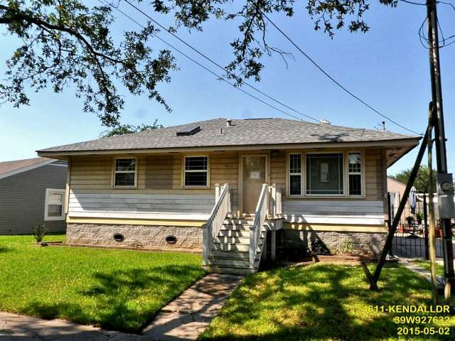
Address: 4611 Kendall Drive

Neighborhood: Gentilly

Homeowner: Charles and Cynthia Heisser

Age: 85 & 83

Hometown: New Orleans, LA

Living in the house since: 1974

Mr. Charles Heisser and Mrs. Cynthia Heisser, have lived in their Gentilly home for decades. Both born and raised in New Orleans, they are very deeply committed to their city and their country. Mr. Heisser proudly served the U.S. Army in the Korean War. They relish in their retirement by spending time with their family and going to church.

After Hurricane Katrina when ensuing levee failure caused catastrophic flooding in their neighborhood, they considered moving away. They ultimately couldn’t bear to part with the home where they raised five children and successfully put them all through college. Unfortunately unscrupulous contractors, costly repairs, and an unfair distribution of rebuilding funds left the Heisser's short of the finish line. The home was lifted, foundation repaired, exterior replaced, and re-framed.

The Heisser's used what they had left to convert a 12x24 garage behind their home into their residence. Every day they wake up behind their unfinished home hoping that they can put the money together to finally get back home. The couple demonstrates a tremendous amount of grit and determination to live comfortably in their house.

With the help of volunteers and supporters, we intend on bringing them home. Volunteers for this project will assist with the installation of insulation and drywall. Additionally, volunteers will make repairs to the rear exterior siding and vapor barrier. Once these repairs are made the Heissers can enjoy their family home with enough space to host all of their children and grandchildren.

