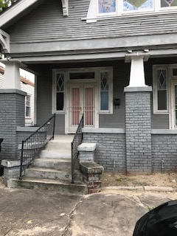
Address: 2013 Frenchmen

Neighborhood: 7th Ward

Homeowner: Betty Johnson

Age: 69

Hometown: Independence, LA

Living in the house since: 1960

Betty Johnson moved to New Orleans in the early 1960’s with her parents and two younger siblings. Ms. Johnson has lived in the 7th ward for most of her life. The Johnson siblings inherited the home when their parents passed. Ms. Johnson’s brother lived on the other side of the double until he passed away. Ms. Johnson also has one daughter who she adores and spends a lot of time with.

Ms. Johnson currently lives alone and is retired from her many years as a state employee in the Medicaid department. Ms. Johnson now spends her time volunteering with the Kiwanis Club, sewing dolls to send to sick kids in the local hospitals. She loves sewing and often teaches sewing classes to young girls at her church. She says, “I have this gift and now that I’m retired I can share it with others who want to learn”.

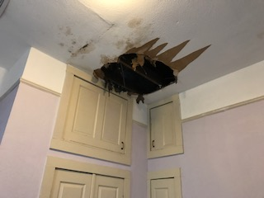
Ms. Johnson is very friendly and enormously proud of her home and has been worried about being unable to physically and financially keep up with the maintenance of the home on her fixed income. After the passing of her brother, it’s become financially harder to maintain taxes and basic repairs. After Katrina the house was fully renovated, but contractors didn’t fix the roof. The roof now is in worse condition and has caused for huge holes in the ceilings. With the help of volunteers, Ms. Johnson will receive much needed assistance to bring the exterior and roof back to life. Weatherization repairs will help her remain financially independent on her limited income of social security and retirement pension. Ms. Johnson said, “I’ve lived here all my life and it’s such a family house my dad worked so hard to get this house and I want to be able to keep it up.”

